Vector Fields

A JangaFX plugin

Support at: [www.jangafx.com](http://www.jangafx.com)

Or on discord: <https://discord.gg/Rwxw5Rs>

Follow JangaFX at: www.twitter.com/JangaFX

# What can you do?

* Import vector fields made in VectorayGen ([www.jangafx.com](http://www.jangafx.com))
* Use the vector fields to control particles and rigid bodies in unity.
* Have particles and rigidbodies react to all fields, or a custom subset.
* Emit particles from different locations inside the vector field (surface, edges, corners ...)
* Animate the intensity of the vector field over time.
* Scale, rotate and move the vector fields like any other objects.

# QuickStart:

* Check the provided samples in the VectorFields/Scene directory.
* Check the tutorial on youtube

# Components:

## Vector Field

To create a Vectorfield, first, create an empty GameObject (GameObject>Create empty) and add the VectorField component (Vector Field>Vector Field).

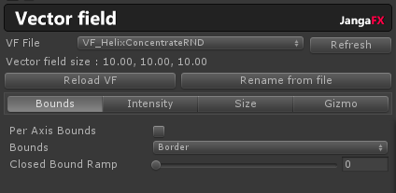

First, select the Vector Field file from which you will import the data. The file must be a .fga file and be anywhere in the asset directory of your project.

The VF File dropdown will list all the Vector Field found in your project (including the sample ones from the plugin). If your file is not present because you have just imported it, just click on the Refresh button on the right of the dropdown).

One selected you will see the Vector Field in the viewport. To reload a file you’ve modified, click ‘Reload VF’.

If you want to quickly rename your GameObject with the filename of your Vector Field, click ‘Rename from file’.

### Vector Field – Bounds:

Per Axis Bounds:

* If checked, you can define different behaviors on the X, Y and Z axis of the VF.

Bounds: Defines the behavior outside the bounding box of the VF.

* Border: The VF values on the surface will be repeated indefinitely. For instance, the vectors on the right side of the VF object will be repeated for all positions on the right, same goes for the other directions.
* Repeat: The VF is duplicated indefinitely, like if you have copies of the VF next to each others.
* Closed (Default): The VF is not active on the outside of the bouding box.
* Mirror: The VF is duplicated like in the repeat mode, but each copy is a mirror of its neighbor (flipped). The vectors direction is not flipped, only the way the values are accessed.

Closed Bound Ramp:

* When a Bound is Closed, this allows a transition ramp from the surface of the VF to the inside of the VF. The higher the value, the longer the transition.
  + If the value is 0, inside the VF is 100%, outside is 0%.
  + If the value is 1, the center of the VF is 100%, the outside is 0% and there is a smooth linear transition between the two.
  + Any in-between values is a transition between these two states.

### Vector Field – Intensity:

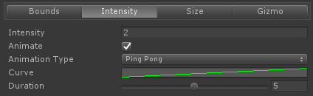

Intensity: Defines the intensity of the VF. Every vectors are multiplied by this value. You can use negative values to invert the way the VF works.

Animate: Check this option if you want to animate the intensity of the VF over time.

Animation type:

* Forward: play the animation curve from start to end.
* Backward: play the animation curve from end to start.
* Ping Pong: play the animation forward, then backward.

Curve: Edit the animation curve of the intensity. The values are multiplied by the Intensity defined above.

Duration: Define the duration of the animation in seconds.

### Vector Field – Size:

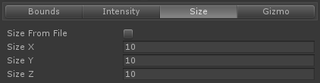

Size from file: If checked (default), the size defined in the file will be used in the scene. Otherwise, you have to define the wanted size.

Size X,Y,Z : Size of the vector field in unity units. Only available when Size from file is unchecked.

### Vector Field – Gizmo:

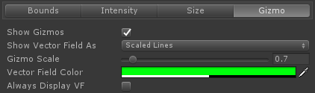

Show Gizmos: If unchecked, you will not see the VF vectors nor the VF bounding box.

Show Vector Field As: Defines the display mode of the VF

* Colored Arrows: Vectors are showed as colored arrows. The color depends on the orientation and the intensity of the color on the magnitude of the vector.
* Scaled Arrows: Vectors are showed as scaled arrows. The size depends on the magnitude of the vectors.
* Colored Lines: Vectors are showed as colored lines. The color depends on the orientation and the intensity of the color on the magnitude of the vector.
* Scaled Lines: Vectors are showed as scaled lines. The size depends on the magnitude of the vectors.
* None: Vectors will not be shown.

Gizmo Scale: Base size of the arrows or lines, depending on the selected option.

Vector Field Color: Used only for Scaled Arrows/Lines. You can also change the alpha of the color

Always Display VF: If checked, the VF vectors will be visible even if the object is not selected.

## Vector Field Rigid Body Controller

To create a rigid body controller, add the RBController component to any object (Vector Field>RigidBody Controller). If a Rigidbody is not present, it will be added automatically.

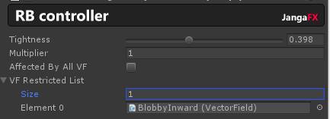

Tightness: Defines the way the VF is applied to the RigidBody Physics. When 1, the VF is 100% applied as velocity and the objects are sticking to the field, when 0, the VF is 100% applied as force (acceleration) and the objects are freer and keep partially their original speed. Anything in-between is a mix of force and speed.

Multiplier: Multiplies all influences of VF affecting this object by this value.

Affected By All VF: If check, all VF in the scene will affect this object, otherwise, you have to define the number of VF affecting it and referencing them in the array below.

## Vector Field Rigid Particle Controller

To create a particle controller, add the Particle Controller component to a particle system (Vector Field>Particle Controller).

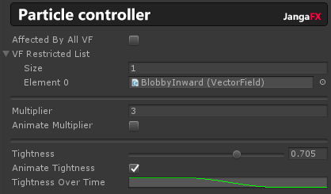

Affected by All VF: If check, all VF in the scene will affect this object, otherwise, you have to define the number of VF affecting it and referencing them in the array below.

Multiplier: Multiplies all influences of VF affecting this object by this value.

Animate Multiplier: If checked, the multiplier will be modulated by an animation curve that you define in Multiplier Over Time. This animation curve will modify the intensity of all VF according to the lifetime of the particle.

Tightness: Defines the way the VF is applied to the Particle Physics. When 1, the VF is 100% applied as velocity and the particles are sticking to the VF, when 0, the VF is 100% applied as force (acceleration) and the objects are freer and keep partially their original speed. Anything in-between is a mix of force and speed.

Animate Tightness: If checked, the thightness will be modulated by an animation curve that you define in Tightness Over Time. This animation curve will modify the tightness of the particles according to its lifetime.

## Vector Field Rigid Particle Emitter

To create a particle emitter, add the Particle Emitter component to a particle system (Vector Field>Particle Emitter).

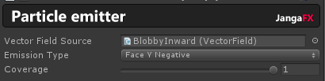

This component allows you to modify the emission source of the particles.

Vector Field Source: Define the VF that is used as source of the particles. If no VF is defined, particles won’t be spawned.

Emission Type: Spawn position of the particles

* Vectors Origins: Particles are spawned at the base of Vectors in the VF.
* Inside Field: Particles are spawned at a random position in the bounding box.
* Corners: Particles are spawned at corners of the bounding box.
* Edges: Particles are spawned on the edges of the bounding box.
* Surface: Particles are spawned on the surface of the bounding box.
* Face xxx: Particles are spawned on the given face of the bounding box.

Coverage: By default, 1, which implies that the particles are spawned on the complete Edge, Surface, Face … Any values lower than 1 reduces the emission surface.

Using a value of 0 with

* Edges, spawns the particles in the middle of the edges.
* Surface, spawns the particles in the center of the faces.
* Inside Field, spawns the particles right in the center of the bounding box.
* Face, spawns the particles right in the center of the face.

**Credits**

This tool was made by Gil Damoiseaux at Ignishot for JangaFX

<http://twitter.com/Ignishot>

<http://twitter.com/Gaxil>